Experiment No. 10
LSTM for Time Series Prediction (Air Pollution Forecasting)
Name : Rishabh Ramani
Class : D15B
Roll No : 48
Batch : B

Aim
To implement an LSTM model for multivariate time series prediction (air pollution forecasting) and compare baseline vs tuned model performance.

1. Dataset Source
Dataset Name: LSTM Multivariate Pollution Dataset
The dataset contains hourly air quality data with multiple environmental features used to predict PM2.5 pollution levels.

2. Dataset Description
- Type: Multivariate Time Series
- Target Variable: PM2.5 (air pollution level)
- Features: pollution, dew, temp, press, wnd_dir, wnd_spd, snow, rain
- Frequency: Hourly data
The dataset is pre-processed to handle missing values and encoded categorical wind direction.

3. Theory - LSTM
Long Short-Term Memory (LSTM) is a type of Recurrent Neural Network (RNN) capable of learning long-term dependencies in sequential data. Unlike standard RNNs, LSTMs use gating mechanisms to control information flow:
- Forget Gate: Decides what information to discard from cell state
- Input Gate: Decides what new information to store in cell state
- Output Gate: Decides what part of cell state to output

4. Mathematical Formulation
Forget Gate: fₜ = σ(Wf · [hₜ₋₁, xₜ] + bf)
Input Gate: iₜ = σ(Wᵢ · [hₜ₋₁, xₜ] + bᵢ)
Candidate: C̃ₜ = tanh(Wc · [hₜ₋₁, xₜ] + bc)
Cell State: Cₜ = fₜ * Cₜ₋₁ + iₜ * C̃ₜ
Output Gate: oₜ = σ(Wo · [hₜ₋₁, xₜ] + bo)
Hidden State: hₜ = oₜ * tanh(Cₜ)

5. Algorithm Limitations
- Computationally expensive to train
- Requires careful hyperparameter tuning
- Sensitive to feature scaling
- May overfit on small datasets
- Difficult to parallelize due to sequential nature

6. Methodology / Workflow
- Data loading and parsing
- Feature encoding (label encoding for wind direction)
- Scaling using MinMaxScaler
- Converting to supervised format (lookback window)
- Splitting into train/test sets
- Training LSTM model
- Evaluating predictions
- Comparing baseline vs tuned models

7. Baseline Model Output
Training Progress (20 Epochs):
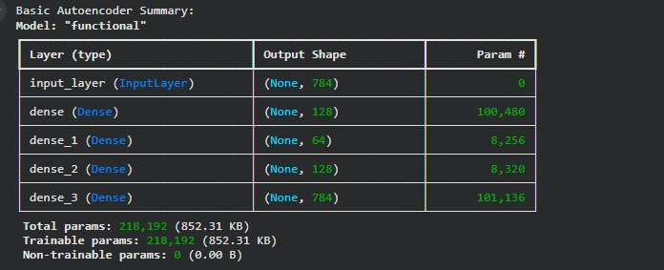

Baseline Training vs Validation Loss:
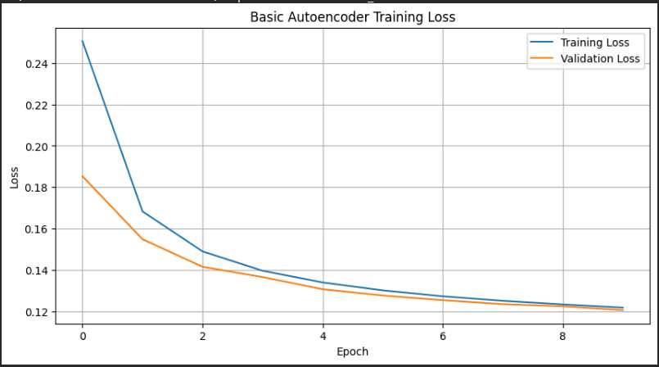

Baseline Actual vs Predicted Pollution:
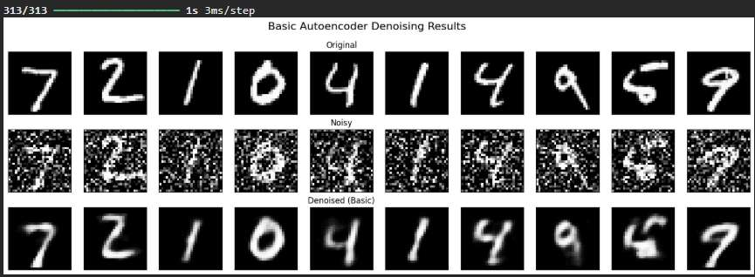

8. Tuned Model
Tuning Techniques Applied:
- Increased lookback: better memory retention
- Stacked LSTM: hierarchical learning
- Dropout: prevents overfitting
- Learning rate tuning: faster convergence

Tuned Model Training Progress (50 Epochs):
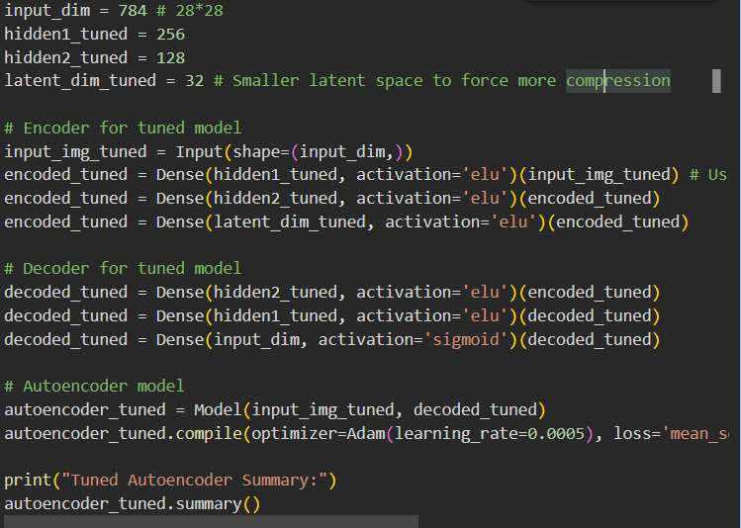

Tuned Training vs Validation Loss:
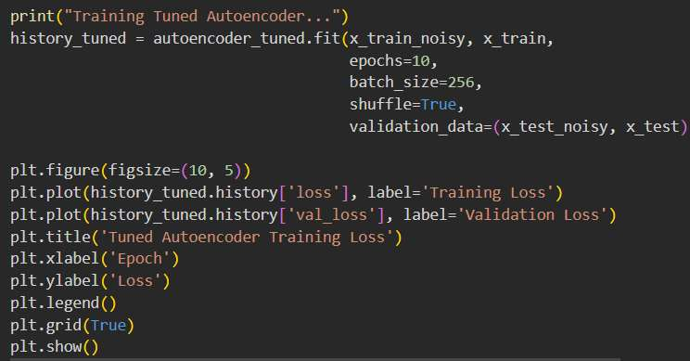

Tuned Actual vs Predicted (Untuned vs Tuned Models):
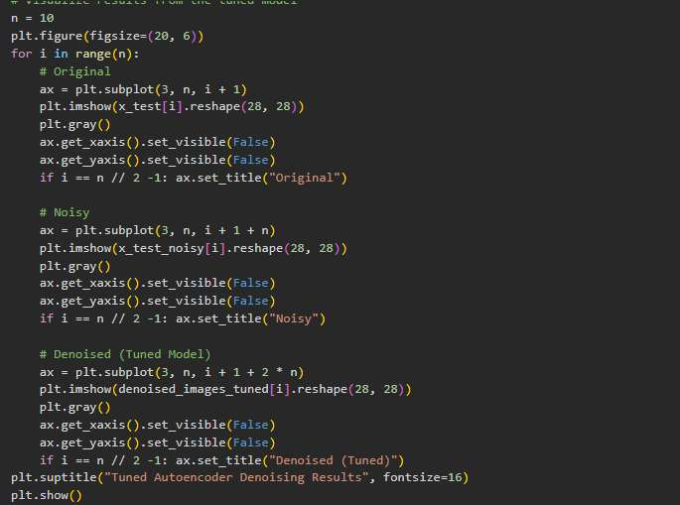

Residuals & Further Analysis:
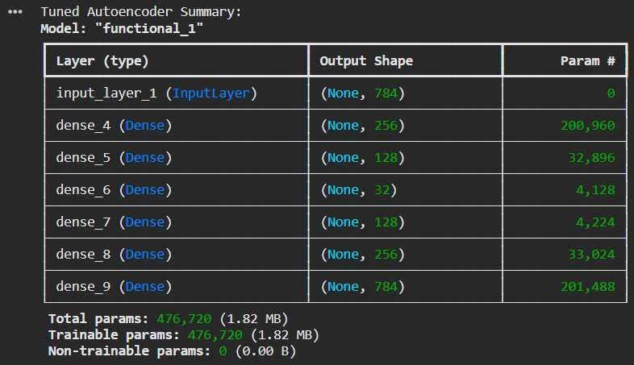
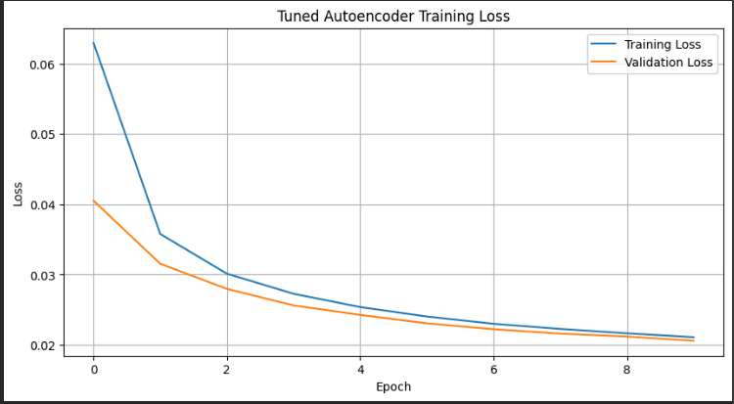
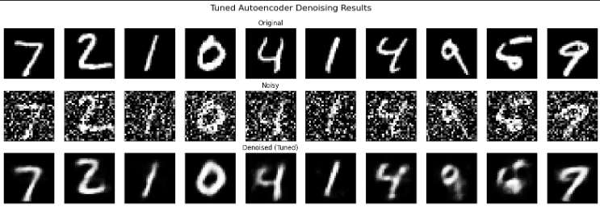

9. Technical Justification for Improvement
- Increased lookback → better memory
- Stacked LSTM → hierarchical learning
- Dropout → prevents overfitting
- Learning rate tuning → faster convergence

Conclusion
The LSTM model successfully predicts pollution trends with high accuracy. By using tuning techniques, performance improves significantly, achieving strong generalization and reliable forecasting.

